Ruh.ai V1 Employee Pack Specification
  - Reusable packaging standard for governed digital employees built on OpenClaw gateway runtimes
Document type | Version | Status | Date
System contract | 1.0 | Working draft | 7 March 2026

What this document does. It defines the reusable pack format, authoring rules, collaboration contracts, governance model, validation gates, and deployment lifecycle used to create digital employees that can work together across many customers without forking the product.

Companion documents. Use this specification together with the platform PRD, the V1 System Design & MVP Execution Blueprint, and the V1 API & Event Contract Specification. The pack spec is the bridge between architecture and deployable employees.

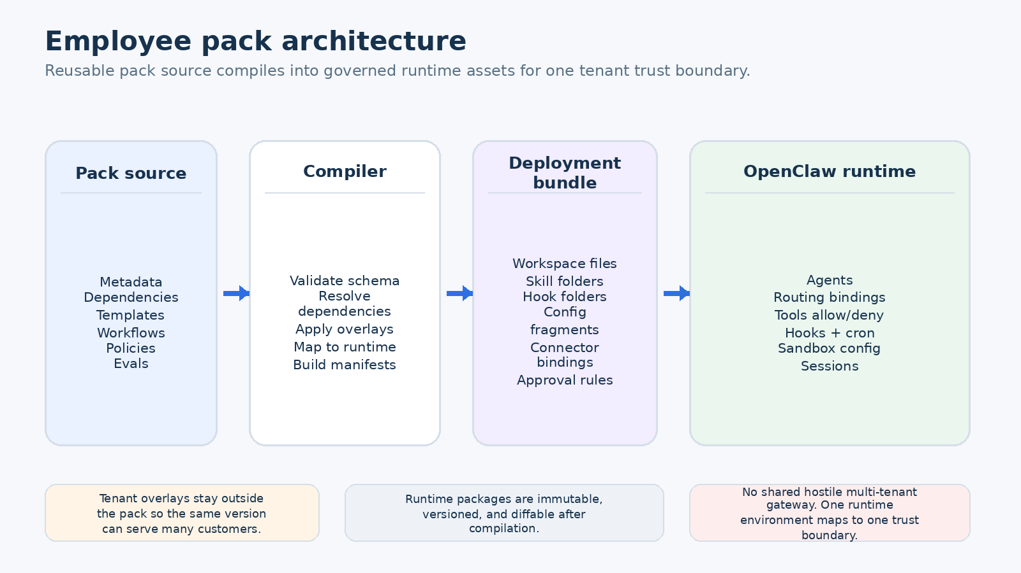
Figure 1. The employee pack is the reusable source artifact; tenant overlays and runtime bundles stay separate.
Executive snapshot
A pack is the highest-level reusable product artifact in Ruh.ai. It is the unit that product, solution engineering, and platform engineering can author once and deploy many times. A pack does not represent a single tenant deployment. Instead it packages customer-neutral definitions for employee roles, workflow contracts, artifact schemas, approval logic, connector mappings, and eval suites.
The central design decision is that packs remain declarative by default and customer-specific values live in overlays. That gives Ruh.ai a way to serve multiple construction companies, software teams, and other future industries without cloning prompts or maintaining one-off agent workspaces for each customer.
Packs must compile deterministically into runtime bundles for one trust boundary at a time.
Packs must support cooperating employees through typed tasks, shared artifacts, locks, and approvals - not uncontrolled cross-chat.
Packs must be promotable through dev, staging, and production without source edits.
Pack releases are immutable, versioned, signed, and observable after deployment.
1. Purpose, scope, and non-goals
This document defines the build contract for Ruh.ai employee packs. It specifies what a pack is, how it is structured, how it maps to OpenClaw runtime assets, what may vary by tenant and environment, how employees inside a pack collaborate, and what validation a pack must pass before release.
The target audience is the platform team, runtime team, solution engineers, pack authors, and design-partner implementation leads. A pack author should be able to build or update a reusable industry solution without inventing new directory structures, schema names, or deployment conventions.
1.1 This document is not
It is not a customer proposal or sales deck.
It is not the low-level REST or event schema; those live in the API & Event Contract Specification.
It is not a promise that every future pack feature ships in V1. Anything not marked v1-safe is aspirational.
It is not a permission slip for arbitrary code inside production packs.
2. Design constraints inherited from OpenClaw
The pack system exists above OpenClaw, but it must respect OpenClaw’s runtime model. OpenClaw already provides isolated agents with workspaces, auth, routing bindings, typed tools, hooks, and cron scheduling [R1][R2][R3][R4]. OpenClaw also expects workspace bootstrap files such as AGENTS.md, SOUL.md, USER.md, IDENTITY.md, TOOLS.md, HEARTBEAT.md, BOOT.md, and BOOTSTRAP.md [R5].
The most important boundary condition is security. OpenClaw explicitly documents a personal-assistant trust model: one trusted operator boundary per gateway, not a hostile multi-tenant shared bus [R6]. Its workspace is the default working directory but not a hard sandbox unless sandboxing is enabled [R5]. Sandboxing is optional, Docker-based, and configurable by mode, scope, and workspace access [R7][R8].
The pack specification therefore assumes that Ruh.ai supplies the enterprise control plane and uses OpenClaw as a trust-bounded runtime operating layer. Every compiled deployment targets one runtime environment for one tenant trust boundary.
OpenClaw fact | Why the pack spec must care
Agents manage isolated workspaces, auth, and routing bindings [R1]. | A template must compile into a clear agent identity, workspace tree, and channel routing plan.
Skills are directory-based, AgentSkills-compatible folders with precedence across bundled, managed, and workspace locations [R2]. | Pack authors need a standard way to ship reusable skill assets without relying on ad hoc prompt files.
Hooks are discovered from workspace, managed, and bundled directories [R3]. | Pack automation must declare where hook behavior comes from and whether it is safe for production promotion.
Tool access can be allow/deny controlled globally and per agent [R4]. | Every employee template needs an explicit tool profile instead of relying on default tool exposure.
Workspace files are injected into prompt context and large files are truncated beyond configured limits [R5][R9]. | Prompt assets inside a pack require size budgets and a compile-time lint step.
OpenClaw supports optional sandboxing with workspace access modes none, ro, and rw [R7][R8]. | Each employee template must declare its minimum sandbox posture and whether host workspace access is required.
3. Why employee packs exist
Without a pack abstraction, every customer deployment becomes a bespoke collection of prompts, connector secrets, cron jobs, and runtime tweaks. That approach does not scale across the construction industry or any other industry because knowledge stays trapped inside one-off workspaces and field engineers become the integration layer.
Packs solve that by separating four concerns that should not be mixed together: reusable business logic, customer-specific configuration, compiled runtime assets, and live operational data.
Reusable business logic belongs in the pack source: templates, workflows, artifact schemas, eval suites, policies, and connector mappings.
Customer-specific values belong in overlays: project keys, distribution lists, allowed channels, branding strings, approval groups, and connector installation refs.
Compiled runtime assets belong in versioned deployment bundles: workspace files, skill folders, hook refs, routing bindings, and config fragments.
Operational state belongs in Ruh.ai resources and logs: work items, tasks, artifacts, approvals, run telemetry, and outcomes.
Design rule. A pack release must stay customer-neutral. If a solution cannot be deployed to a second customer without editing the pack source, it is not a valid pack - it is a bespoke implementation.
4. Canonical pack model
A pack is an immutable, versioned distribution unit. It may depend on other packs, export one or more employee templates and workflows, and declare the policies, schemas, assets, and evals required to deploy those exports safely.
4.1 Pack types
Pack type is a classification field, not a security boundary. V1 supports three types.
Pack type | Intent | Typical contents
foundation | Cross-industry primitives shared by many solutions. | Common artifact schemas, generic employee templates, baseline policies, utility skills, and shared eval patterns.
domain | Industry or functional specialization built on top of foundation packs. | Construction operations workflows, document-control templates, or BuildOps templates for AI product teams.
solution | Opinionated composition intended for fast deployment. | Selected templates, starter workflows, dashboards, default policies, and connector profiles designed for a particular solution motion.
4.2 Canonical objects inside a pack
Object | What it defines | Cardinality in one pack
Pack manifest | Identity, compatibility, dependencies, exports, and allowed overlays. | Exactly one
Employee template | A reusable role contract that can compile into a runtime employee. | One or more
Workflow template | State machine, task graph, assignee rules, and artifact expectations. | Zero or more
Task contract | Typed input and output schema for a unit of work. | Zero or more
Artifact schema | Persisted business object produced or consumed by workflows. | Zero or more
Policy profile | Approval thresholds, tool restrictions, sandbox posture, and write-back rules. | Zero or more
Connector profile | Normalized capabilities mapped to provider-specific operations. | Zero or more
Eval suite | Quality gates, test fixtures, scoring rubrics, and pass thresholds. | Zero or more
Asset bundle | Prompt fragments, skill folders, reference docs, images, and examples. | Zero or more
5. Mapping pack objects to OpenClaw runtime assets
Packs do not run directly. The deployment compiler converts them into runtime bundles that OpenClaw can execute. The mapping must be explicit and deterministic so that pack authors do not need to hand-edit gateway files during deployment.
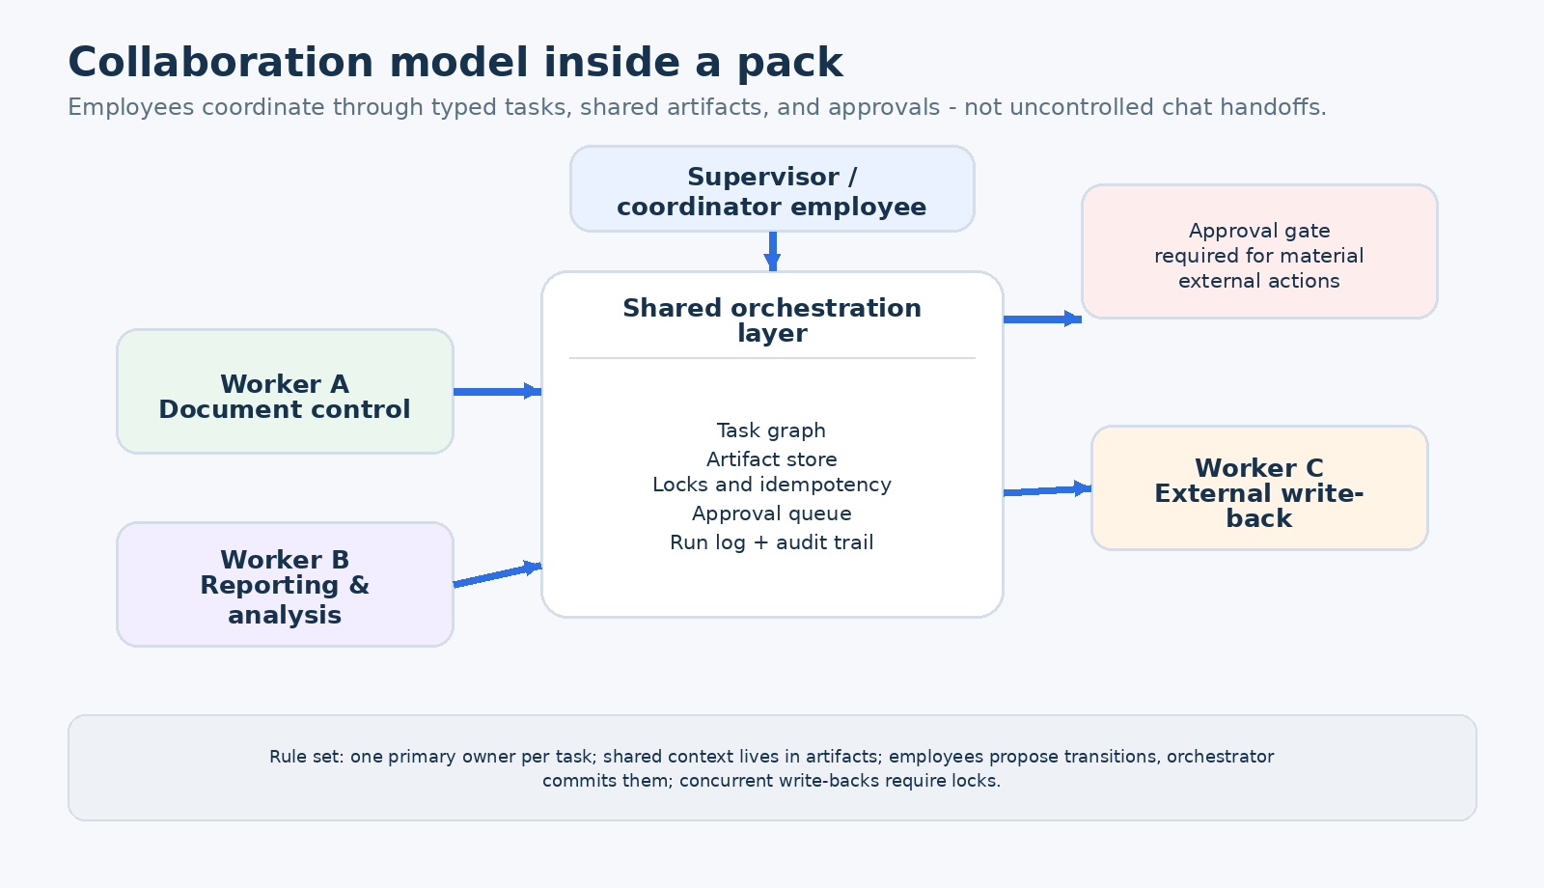
Figure 2. Recommended collaboration pattern inside a pack: supervisor coordinates workers through shared orchestration resources.
Ruh.ai pack object | Compiled OpenClaw target | Notes
Employee template | agents.list[] entry + workspace root + routing bindings | Includes identity, workspace path, tool profile, model profile, and channel routing plan.
Prompt assets | Workspace files such as AGENTS.md, SOUL.md, USER.md, IDENTITY.md, TOOLS.md, HEARTBEAT.md, BOOT.md | Compiler controls file size and injection order.
Skill asset | workspace/skills/<skill>/SKILL.md or managed skill directory | Use workspace-level install by default for reproducibility; managed install only for signed shared assets.
Hook reference | workspace/hooks/<hook> or managed hook package | Raw hook code is restricted in certified releases; curated package refs are preferred.
Tool profile | tools.allow / tools.deny and per-agent tool config | Deny-by-default on high-risk tools for external-facing employees.
Connector profile | Plugin config + connector binding manifest + capability map | Secrets are injected by reference at deployment time, never committed to the pack.
Heartbeat plan | HEARTBEAT.md and/or cron jobs | Use heartbeat for lightweight recurring review and cron for explicit schedules [R10].
Sandbox profile | agents.defaults.sandbox or agents.list[].sandbox | Pack declares minimum required posture; runtime may tighten it further.
6. Pack directory and file structure
Every pack release resolves to a canonical source tree. The source tree must be small enough for code review, structured enough for tooling, and strict enough to prevent pack authors from hiding important behavior in untracked files.
6.1 Required root files
Path | Required | Purpose
pack.yaml | Yes | Primary manifest for identity, compatibility, dependencies, exports, overlay policy, and release metadata.
README.md | Yes | Human-readable overview, pack intent, included templates, and deployment notes.
CHANGELOG.md | Yes | Release history and upgrade notes.
LICENSE.md | Optional | Needed if distribution rules differ by pack source.
examples/ | Optional | Sample overlays, test payloads, and walkthrough scenarios.
6.2 Standard directories
Directory | Contents | V1 rule
templates/ | Employee template manifests and prompt assets. | Required if the pack exports employee templates.
workflows/ | Workflow graphs, state machines, and task contracts. | Required if the pack exports workflows.
artifacts/ | Artifact schemas, render configs, and document mappings. | Recommended for any pack that persists business state.
policies/ | Approval, sandbox, tool, and risk profiles. | Required for any template that can produce side effects.
connectors/ | Capability maps, connector presets, and binding schemas. | Required when the pack integrates with external systems.
skills/ | Reusable skill folders shipped with the pack. | Optional, but preferred over long AGENTS.md files for tool guidance [R2].
evals/ | Fixtures, scoring rubrics, thresholds, and regression suites. | Required for certified releases.
assets/ | Images, reference docs, UI metadata, and pack diagrams. | Optional.
mappings/ | Compiler mapping files from pack objects to runtime outputs. | Required when defaults are not enough.
migrations/ | Upgrade or data migration descriptors between pack versions. | Optional in V1, required once breaking data changes appear.
pack/
pack.yaml
README.md
CHANGELOG.md
templates/
triage/
template.yaml
prompts/
AGENTS.md
SOUL.md
TOOLS.md
HEARTBEAT.md
workflows/
issue_to_resolution.workflow.yaml
contracts/
intake_task.schema.json
artifacts/
triage_packet.schema.json
summary_report.schema.json
policies/
tool_profiles/
approval_profiles/
sandbox_profiles/
connectors/
github.binding.yaml
slack.binding.yaml
skills/
evidence_summarization/
SKILL.md
evals/
core/
smoke.yaml
regression.yaml
assets/
icons/
docs/
mappings/
runtime_map.yaml
6.3 Executable content rules
V1 prefers declarative packs. Markdown, YAML, JSON, images, and static reference files are allowed by default. Executable behavior is much more restricted because OpenClaw plugins and host-side extensions live inside the runtime trust boundary [R6].
Certified production packs may not embed raw secrets, API keys, OAuth tokens, or customer IDs.
Certified production packs may not rely on arbitrary shell scripts or unreviewed binaries.
Hook or plugin behavior should be referenced through curated package IDs and pinned versions. Inline source is allowed only in internal developer mode and must be converted to signed package refs before promotion.
The publish pipeline must scan the pack tree for executable files, unknown file types, and unresolved external references.
7. Pack manifest specification
The root manifest is the pack’s source of truth. It must declare what the pack exports, what it depends on, which overlays are allowed, and which platform and runtime versions are compatible. Nothing outside the manifest may silently change the identity of a pack release.
7.1 Required manifest fields
Field | Type | Meaning
apiVersion | string | Schema version for the pack format, e.g. ruh.ai/v1alpha1.
kind | enum | Always EmployeePack for this document.
metadata.id | string | Globally unique pack identifier.
metadata.version | semver | Immutable released version for the pack.
metadata.title | string | Human-readable pack name shown in studio and registry.
metadata.packType | enum | foundation | domain | solution.
compatibility.platform | range | Supported Ruh.ai platform versions.
compatibility.runtimeAdapter | range | Supported Ruh runtime adapter versions.
compatibility.openclaw | range | Supported OpenClaw runtime range used by certified bundles.
dependencies[] | list | Other packs or shared assets required by this pack.
exports | object | Templates, workflows, artifact schemas, and presets exposed to downstream users.
overlays.allowed[] | list | Field paths that tenants or environments may override without forking the pack.
security | object | Executable-content mode, default sandbox posture, and release hardening requirements.
apiVersion: ruh.ai/v1alpha1
kind: EmployeePack
metadata:
id: ai-buildops
version: 1.2.0
title: AI BuildOps Pack
packType: solution
owner: ruh-core
summary: >
Digital employees for intake, specification, build orchestration,
evals, and release preparation.
compatibility:
platform: ">=1.0.0 <2.0.0"
runtimeAdapter: ">=1.0.0 <2.0.0"
openclaw: ">=2026.2 <2027.0"
dependencies:
- id: foundation-core
version: "^1.4.0"
exports:
templates:
- buildops.triage
- buildops.spec
- buildops.release
workflows:
- issue_to_pull_request
overlays:
allowed:
- vars.brand.displayName
- vars.sla.defaultHours
- connectors.github.installationRef
- connectors.jira.projectKey
- policies.externalWriteback.approverGroup
security:
executableContent: curated_code_refs_only
defaultSandboxMode: all
defaultWorkspaceAccess: none
7.2 Overlay rules
Overlay policy is the mechanism that keeps packs reusable. A pack release must explicitly list which fields may vary after publish. Everything else is immutable. That prevents silent drift between customers and ensures that release quality remains meaningful.
Allowed overlays should focus on values, not behavior: names, project keys, channel ids, approval groups, connector installation refs, distribution lists, and SLA targets.
Behavioral changes such as workflow topology, tool exposure, or risk tier should require a new pack version unless the manifest explicitly marks a narrow override point as safe.
Overlay precedence from lowest to highest is: dependency defaults → pack defaults → solution preset → tenant overlay → environment overlay → emergency deployment flags.
Only fields marked overridable in the manifest may participate in precedence resolution.
8. Employee template specification
An employee template is a customer-neutral role contract. It describes what the employee is for, what work it can accept, what outputs it must produce, what context it needs, what tools and capabilities it is allowed to use, what approval rules govern it, and how it collaborates with other employees.
8.1 Required template fields
Field group | Required fields | Intent
metadata | id, title, summary, owner | Identity and display metadata.
role | objective, businessOutcome | What success looks like for this employee.
contracts | accepts, emits | Signal, task, and artifact contracts the employee consumes and produces.
context | workspaceFiles, skills, memoryProfileRef | What instructions, local notes, and memory policies are injected.
tools | toolProfileRef, requiredCapabilities | Normalized capability need and tool exposure policy.
governance | policyProfileRef, riskTier | Approval and side-effect controls.
execution | modelProfileRef, sandboxProfileRef | Runtime model selection and isolation posture.
collaboration | delegatesTo, supervisorEligible | How the employee participates in teamwork.
evals | suiteRefs | Quality gates required before promotion.
apiVersion: ruh.ai/v1alpha1
kind: EmployeeTemplate
metadata:
id: buildops.triage
title: Intake & Triage Employee
summary: Normalize inbound work into typed work items.
role:
objective: >
Convert messy incoming signals into a clean work item with severity,
route, evidence links, and next-step recommendation.
contracts:
accepts:
- signal.issue_reported
- signal.alert_opened
- signal.customer_feedback
emits:
- work_item.normalized
- artifact.triage_packet
context:
workspaceFiles:
agents: prompts/triage/AGENTS.md
soul: prompts/common/SOUL.md
tools: prompts/common/TOOLS.md
heartbeat: prompts/triage/HEARTBEAT.md
skills:
- skills/evidence_summarization
- skills/issue_classification
memoryProfileRef: policies/memory/short_context.yaml
tools:
toolProfileRef: policies/tool_profiles/triage_lowrisk.yaml
requiredCapabilities:
- messages.read
- files.read
- issues.create
- artifacts.write
governance:
policyProfileRef: policies/approval_profiles/triage.yaml
riskTier: L1
execution:
modelProfileRef: models/reasoner_medium.yaml
sandboxProfileRef: policies/sandbox/all_none.yaml
collaboration:
supervisorEligible: true
delegatesTo:
- buildops.spec
evals:
suiteRefs:
- evals/core/triage_smoke.yaml
- evals/core/triage_regression.yaml
8.2 Workspace and prompt asset mapping
OpenClaw loads operating instructions from workspace files and may also read skills on demand [R2][R5]. Pack authors should therefore split long, reusable tool guidance into skills and keep workspace files concise, specific, and bounded by purpose.
Workspace asset | What it should contain | Pack authoring rule
AGENTS.md | Role instructions, priorities, work norms, memory behavior, and decision policy. | Keep role-specific and concise; avoid copying connector specifics that belong in TOOLS.md or skills.
SOUL.md | Tone, persona, boundaries, and interaction style. | Small and stable across many templates where possible.
USER.md | How the employee should address operators or end users. | Usually populated from overlays, not hard-coded.
IDENTITY.md | Name, vibe, avatar metadata. | Brandable through overlays; never used for core business logic.
TOOLS.md | Local conventions, aliases, and environment-specific notes. | Prefer tenant overlays or connector metadata instead of free-form customer prose.
HEARTBEAT.md | Short recurring review checklist. | Keep tiny to reduce token burn [R10].
BOOT.md / BOOTSTRAP.md | Startup or first-run rituals when explicitly needed. | Avoid pack dependence on one-time human rituals in customer production environments.
skills/*/SKILL.md | Reusable tool usage guidance and step-specific instructions. | Preferred place for reusable methods and procedures [R2].
8.3 Prompt and context budgets
Because OpenClaw injects workspace and bootstrap files into the prompt context, large files can increase cost and truncate important instructions [R9]. The compiler must run context-budget linting on every template.
Warn when any single injected workspace file approaches the OpenClaw per-file limit.
Warn when combined auto-injected files and required skill instructions exceed the tenant’s configured context budget.
Reject templates that rely on enormous AGENTS.md files instead of modular skills.
Prefer on-demand memory retrieval for large reference corpora instead of auto-injected prose.
9. Workflow, task contract, and collaboration specification
Packs become valuable when many employees can coordinate on repeatable work. Collaboration must happen through typed tasks and structured artifacts, not improvised message passing. The orchestrator remains the owner of business state; employees produce proposals and outputs.
9.1 Workflow template fields
Field | Purpose
workflow.id / title | Stable identifier and display name.
triggerContracts[] | Signals, events, or manual actions that can start the workflow.
taskGraph | Ordered or conditional tasks, dependencies, and assignment rules.
stateMachine | Allowed lifecycle states and transitions for work items and tasks.
artifactBindings | Which artifact schemas are produced, read, or updated at each step.
approvalCheckpoints | Where human approval is required before progress may continue.
slaTargets | Timers, due dates, escalation windows, and retry budgets.
lockPolicy | Concurrency rules for write-backs or shared records.
9.2 Collaboration rules
Each task has exactly one primary assignee at any time.
Employees may request subtasks, but only the orchestrator creates official task records and assigns ownership.
Shared business context lives in artifacts and task fields; private scratch work remains inside employee sessions and workspaces.
Two employees must not write back to the same external record concurrently without a lock or optimistic concurrency check.
Employees may propose a state transition, but the orchestrator commits it only after contract validation and approval checks pass.
External outbound messages, published files, ticket mutations, or irreversible writes route through an approval policy unless explicitly classified low-risk.
9.3 Canonical collaboration patterns
Pattern | When to use it | Example
Supervisor + workers | A coordinating employee assigns specialized subtasks to others. | Reporting coordinator assigns evidence gathering to a document-control worker and summary writing to an analysis worker.
Pipeline handoff | Work always follows the same ordered sequence. | Issue intake → spec → builder orchestration → eval → release.
Parallel gather, single writer | Several employees research in parallel but only one is allowed to publish. | Construction monitoring employees collect evidence, while a final reporting employee prepares the customer-facing update.
Human gate | High-impact step requires decision by a person or approval group. | External write-back to Jira, Procore, or customer email.
10. Connector and capability specification
Packs should not be hard-wired to a single vendor when the business capability is broader. The specification therefore separates normalized capabilities from provider-specific connector bindings.
10.1 Capability model
Capability class | Examples | Notes
Read | files.read, tickets.read, messages.read, records.read | Low-risk by default but still subject to data-access policy.
Draft | artifacts.write, summaries.generate, forms.prepare | May create internal artifacts without changing external systems.
Write-back | tickets.update, project_records.update, messages.send | Typically approval-gated unless reversible and explicitly low-risk.
Control | cron.manage, sessions.spawn, gateway.control | Denied by default for any employee exposed to outside input.
Execution | repo.pull_request.create, workflow.run, report.publish | May combine internal and external effects; always policy-reviewed.
10.2 Connector binding rules
A pack may declare required capabilities and supported providers, but provider installation refs and secret refs are overlay values.
The connector profile must document which operations are dry-run safe, reversible, approval-required, or forbidden in unattended mode.
The compiler should fail if a template requires a capability that no selected provider mapping can satisfy.
Capability names must stay stable even when provider APIs change; provider-specific churn belongs inside connector adapters, not inside templates.
11. Policy, approvals, and risk controls
Every pack has an implicit risk posture. The specification makes that posture explicit through policy profiles so that customers can understand what each employee may do before anything is deployed.
11.1 Risk tiers
Tier | Meaning | Default policy
L0 | Internal analysis only; no external side effects. | May run automatically if connector and data policies allow read access.
L1 | Internal artifact creation or reversible draft actions. | Auto-run allowed; final external publish still requires escalation path.
L2 | External write-back or outbound communications with meaningful customer impact. | Approval required unless an org-approved exception profile exists.
L3 | Irreversible, high-impact, privileged, or break-glass actions. | Human-only or explicitly break-glass with named approver and audit reason.
11.2 Required policy profile fields
Field | Why it matters
approvalMode | Defines whether a task is auto, approval-required, or human-only.
approvalGroupRef | Links high-impact actions to a human owner or team.
allowedTools / deniedTools | Prevents templates from inheriting unsafe runtime defaults.
channelPolicy | Restricts where the employee may receive requests and where it may send output.
writeBackPolicy | Specifies which systems and record types may be mutated.
auditRequirements | Defines mandatory evidence attached to decisions and write-backs.
sandboxProfileRef | Ensures runtime isolation matches the employee’s risk tier.
quietHours / rateLimits | Prevents automation spam or after-hours behavior.
Non-negotiable V1 rule. Any capability that can publish outward, mutate a customer system, or bypass a safety control must appear in a named policy profile. Silent inherited privilege is not allowed.
12. Evals, tests, and release gates
A pack is only reusable if it can be tested repeatedly. V1 therefore treats evals as first-class pack content, not optional add-ons. Every certified pack release must ship the eval suites needed to prove role behavior, workflow correctness, policy enforcement, and connector safety.
12.1 Eval suite categories
Eval category | What it checks | Typical fixture
Instruction compliance | Whether the employee follows role rules and output structure. | Representative task prompts and expected artifact schema.
Tool choice | Whether the employee selects the right tool or abstains correctly. | Mocked tool availability and desired call pattern.
Workflow routing | Whether tasks route to the correct employee and state transitions. | Signal payloads across happy and edge paths.
Approval behavior | Whether high-risk actions pause for approval. | Simulated outbound send or write-back request.
Connector contract | Whether provider-specific payloads map cleanly. | Dry-run API stubs and fixture responses.
Regression | Whether known failures stay fixed. | Captured failure cases from previous deployments.
Cost and latency | Whether the pack stays within budget envelope. | Synthetic production-like run volumes.
12.2 Publish gates
Schema validation: all manifests, schemas, and references resolve.
Dependency validation: no missing pack deps, no unsupported version ranges, no dependency cycles.
Prompt lint: workspace and skill content stays within configured context budgets.
Compile dry-run: pack compiles into a bundle without unresolved capabilities or illegal overlays.
Connector tests: required provider mappings pass dry-run contract checks.
Policy scan: unsafe tools or channels are rejected for the target risk tier.
Eval threshold: every mandatory suite meets minimum score before publish.
Signing and integrity: release manifest, digests, and trusted publisher signature are recorded.
13. Compilation, overlay application, deployment, and rollback
Publishing a pack does not place it in production. Deployment is a second step that applies overlays, validates environment readiness, and generates a runtime bundle for one tenant trust boundary. The bundle is immutable and tied to the exact pack version, overlay values, and runtime adapter used to build it.
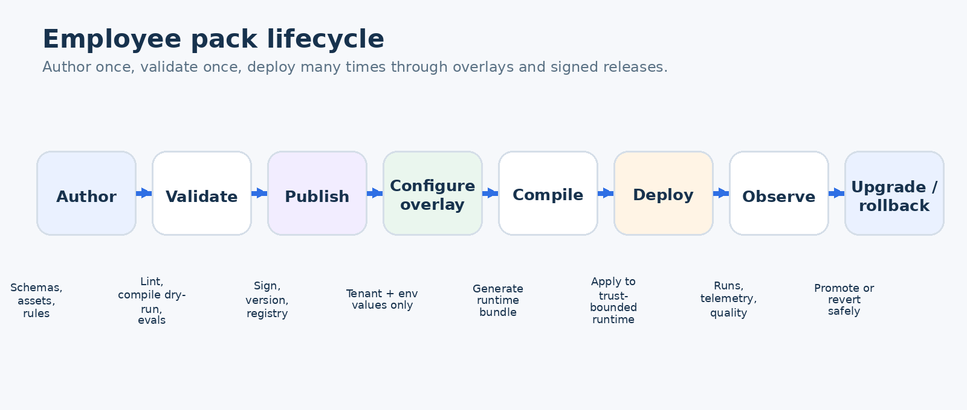
Figure 3. Author once, validate once, and deploy many times using controlled overlays and signed releases.
13.1 Compiler output
Deployment manifest with pack version, dependency graph, overlay values, and artifact digests.
Agent workspace trees and prompt assets for each employee instance.
Skill and hook install plan, including curated package refs and pinned versions.
OpenClaw config fragments: agents list, bindings, tool policy, sandbox config, heartbeat or cron setup.
Connector binding manifest with secret references and provider installation refs.
Rollback bundle pointing to the previous healthy deployment revision.
13.2 Upgrade rules
Patch releases may not break schemas, exported identifiers, or allowed overlay paths.
Minor releases may add templates, workflows, fields, or safer default policies, but must preserve existing exported contracts.
Major releases are required for breaking exported schemas, removed templates, or changed approval semantics.
The deployment service must show a semantic diff between old and new pack versions before promotion.
Rollback must restore the previous runtime bundle and connector/policy mapping without editing pack source.
14. Registry, dependency, and compatibility model
V1 uses a curated private registry. Public marketplace installation is out of scope because production packs may influence tool exposure, hook behavior, and external system writes. The registry is therefore a trust surface, not just a convenience feature.
Concern | V1 rule
Registry visibility | Private registry only; customer tenants can consume approved packs but not install arbitrary public ones.
Dependency resolution | Semantic-version ranges allowed, but certified deployments must resolve to exact versions and digests.
Publisher trust | Only trusted publishers may release production-certified packs.
Compatibility enforcement | Pack install fails if platform, runtime adapter, or OpenClaw range is unsupported.
Deprecation | Deprecated exports remain installable for a defined support window with clear migration notes.
15. V1 authoring and release checklist
The following checklist is the minimum bar for a production-ready pack. The intent is to turn pack quality into a repeatable discipline instead of a manual review ritual.
Area | Acceptance condition
Identity | Pack id, version, compatibility ranges, and exports are present and valid.
Structure | Required directories exist; no stray executable content or secrets in source tree.
Templates | Each exported employee template declares objective, contracts, tool profile, sandbox posture, and eval suite refs.
Workflows | State machine, task ownership, and artifact outputs are explicit.
Policies | Risk tier, approval rules, channel restrictions, and write-back policy are defined.
Connectors | Required capabilities are satisfiable by supported providers.
Context budgets | Injected files and required skills pass prompt lint.
Evals | Mandatory smoke and regression suites pass release thresholds.
Compilation | Dry-run bundle succeeds against at least one supported target environment.
Rollback | Previous version remains deployable and upgrade notes are recorded.
16. Reference pack blueprints for Ruh.ai
To keep the pack system horizontal, Ruh.ai should ship a small set of reference packs that demonstrate reuse across industries. Two strong early examples are shown below because they reflect the company’s current market direction and the broader digital-employee platform thesis.
Reference pack | Included employees | Core workflows | Why it matters
Construction Project Operations Pack | Project intake coordinator, document-control assistant, reporting assistant, action-item chaser. | Daily reporting, RFI/submittal prep, progress summary, follow-up management. | Proves cross-customer reuse in construction without becoming a one-off solution for one subcontractor or one sensor vendor.
AI BuildOps Pack | Intake & triage, spec writer, builder orchestrator, QA & evals, release assistant. | Issue-to-PR, regression-eval loop, release preparation, incident follow-up. | Shows the same pack system can serve AI product companies and validates the platform beyond construction.
Appendix A. Example pack-to-runtime compilation map
template: buildops.triage
compiles_to:
agentId: tenantA-buildops-triage
workspace:
root: /srv/ruh/runtime/tenantA/prod/buildops-triage
files:
AGENTS.md: templates/triage/prompts/AGENTS.md
SOUL.md: templates/common/SOUL.md
TOOLS.md: overlays/prod/TOOLS.generated.md
HEARTBEAT.md: templates/triage/prompts/HEARTBEAT.md
skills:
- workspace/skills/evidence_summarization
- workspace/skills/issue_classification
openclaw:
bindings:
- slack:eng-ops
tools:
allow: [read, web_fetch, message, sessions_history]
deny: [gateway, cron, sessions_spawn, sessions_send]
sandbox:
mode: all
scope: agent
workspaceAccess: none

Appendix B. Source references
The references below anchor the OpenClaw assumptions used in this document. They should be revisited whenever the runtime adapter or pack compiler is updated.
Ref | Source | Link
R1 | OpenClaw agents | https://docs.openclaw.ai/cli/agents
R2 | OpenClaw skills | https://docs.openclaw.ai/tools/skills
R3 | OpenClaw hooks | https://docs.openclaw.ai/automation/hooks
R4 | OpenClaw tools | https://docs.openclaw.ai/tools
R5 | OpenClaw agent workspace | https://docs.openclaw.ai/concepts/agent-workspace
R6 | OpenClaw security model | https://docs.openclaw.ai/gateway/security
R7 | OpenClaw sandboxing | https://docs.openclaw.ai/gateway/sandboxing
R8 | OpenClaw configuration reference | https://docs.openclaw.ai/gateway/configuration-reference
R9 | OpenClaw token use and context budgets | https://docs.openclaw.ai/reference/token-use
R10 | OpenClaw heartbeat guidance | https://docs.openclaw.ai/gateway/heartbeat

